999903753_ShasankRiyala

It is about Web Server and Client implementation

Web Server and Client

Contents

Introduction: 1

Web Server Implementation: 1

Server Information 1

Server Operation 1

Error Handling 1

Web Client Implementation: 1

Client Information 1

Client Operation 1

Connection Parameters: 1

Screenshoots: 1

Conclusion: 2

# Introduction:

In this project, it is aimed to build a multi web threaded server that is able to communicate with its client. Client can communicate with server and read content about file. It is implemented via Sockets using python language

# Web Server Implementation:

## Server Information

Using multi-threaded approach, it is made to handle multi-client requests at a time. Sockets are used to handle these connections

## Server Operation

Using a thread, a client connection is handled. It listens to client requests on a specific port like 8080. Finally, it responds to their requests and provide them file for accessing.

## Error Handling

Server shows 404 error in case of bug

# Web Client Implementation:

## Client Information

Client is implemented via sockets library utilizing single threaded approach to make requests to server for downloading file

## Client Operation

Client make HTTP request to server requesting a file for downloading and on successful connection file will download locally.

# Connection Parameters:

Ip address, Port and http response are basic parameters for connection.

# Screen-shoots:

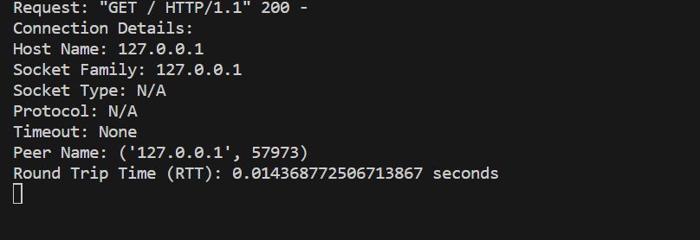



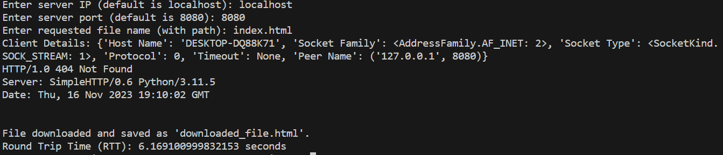

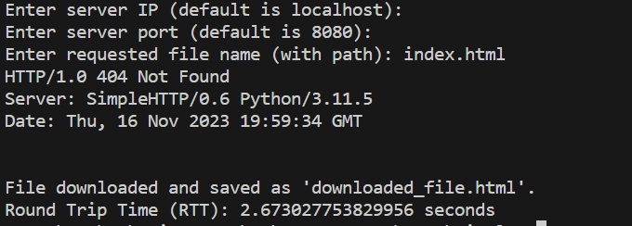

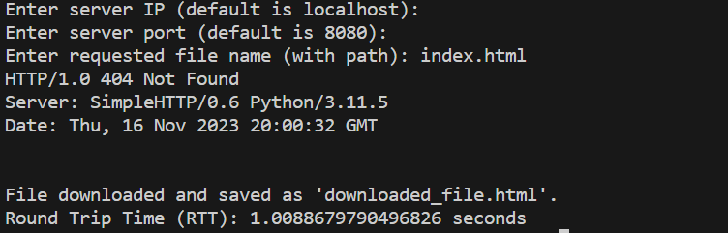

# Conclusion:

Hence, as a conclusion a simple web server and client connection is implemented via sockets. Clients make requests to server for downloading file. On successful connection, file is returned and saved locally. Error handling is also implemented via 404 not found response.